BLOCK CHAIN (ZONE 14)

ASSIGNMENT

K.SANTHOSH

NM ID : 6FDAE930749B66191DC42109FF474E3B

FINAL YEAR CSE

SRI RAAJA RAAJAN COLLEGE OF ENGINEERING AND TECHNOLOGY

TEAM LEADER

PROBLEM

create a program to return your string "ZONE NAME"

PROGRAM

// SPDX-License-Identifier: MIT

pragma solidity ^0.8.10;

contract zonecontract {

function zone(string memory zoneName) public pure returns(string memory){

return zoneName;

}

}

1. Go to the chrome and open remix platform

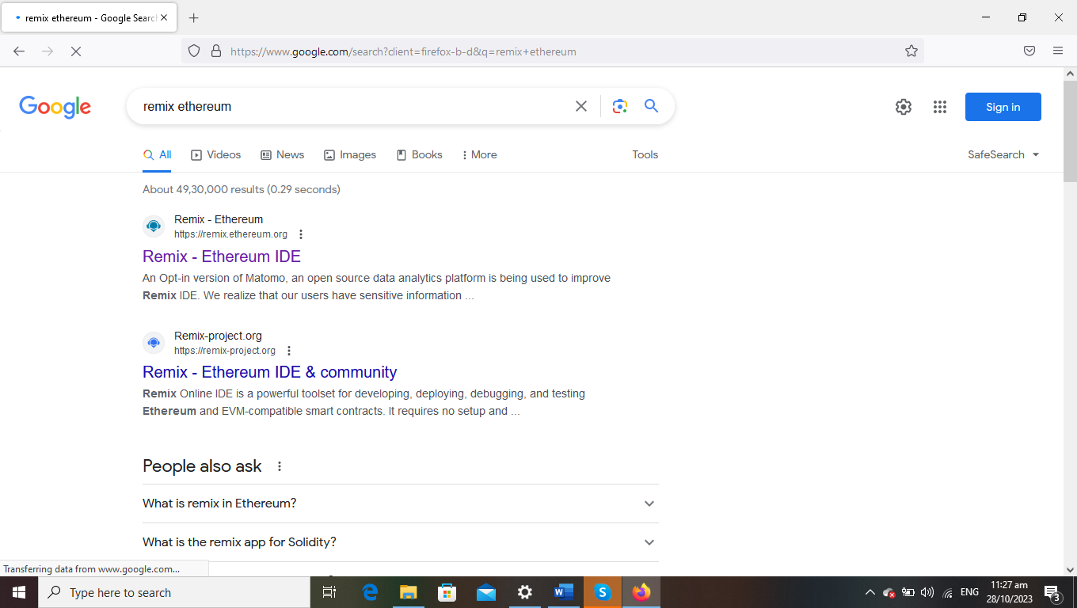

2.Open the remix page and create a new FILE

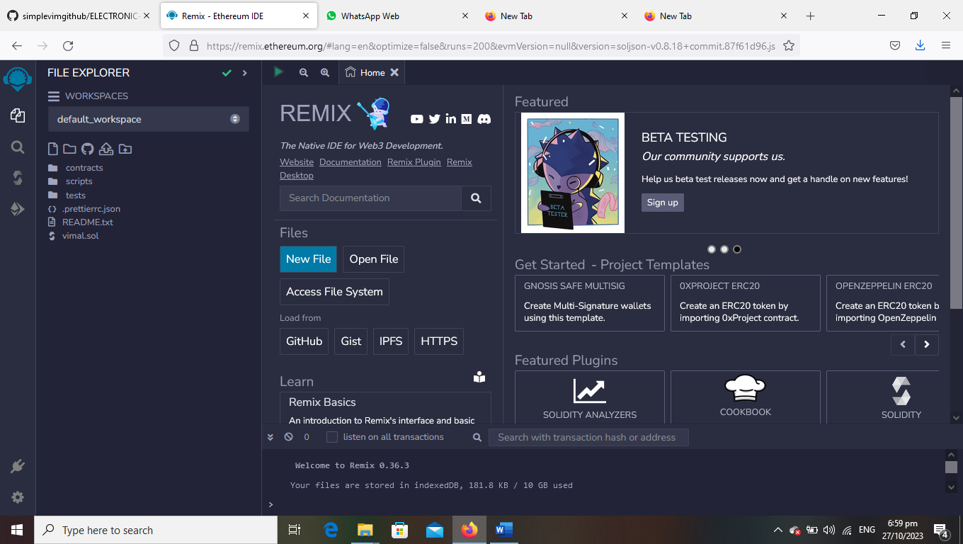

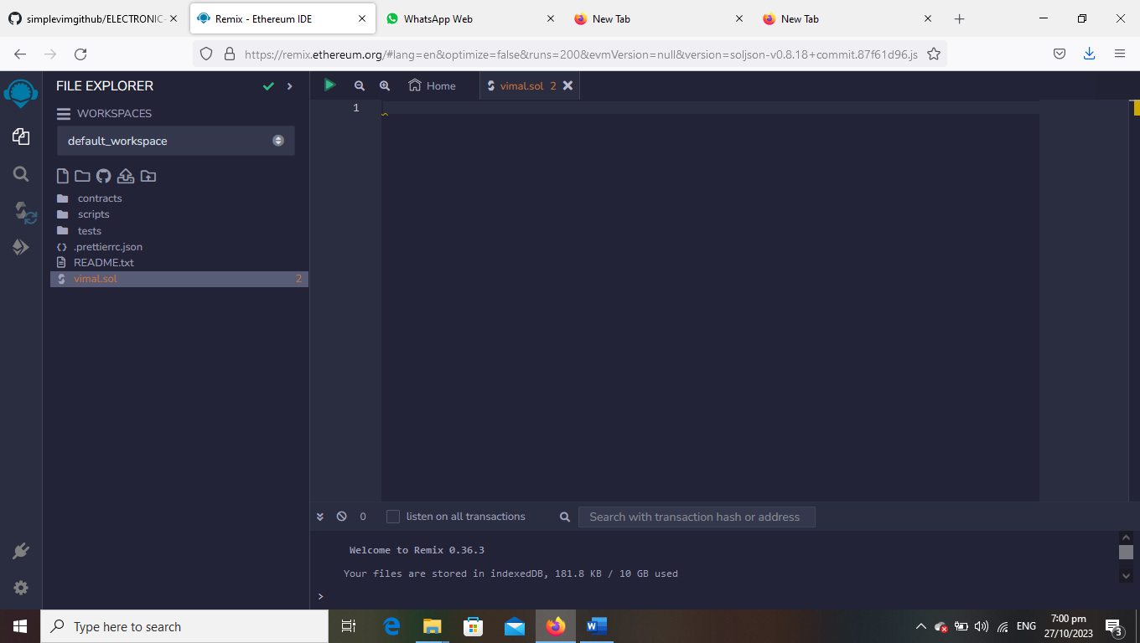

3.create a program to return your string ”ZONE NAME”

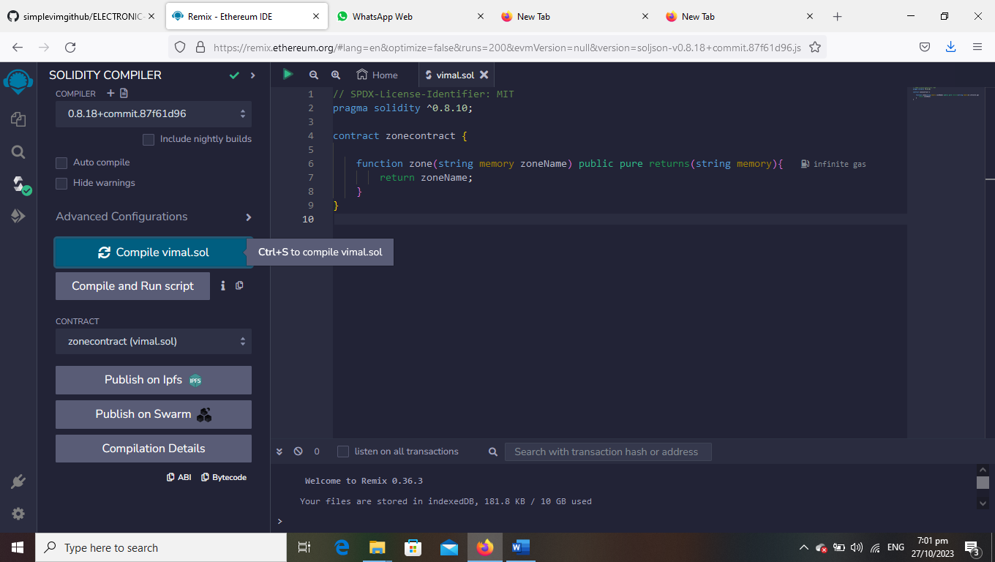

4.compile it det ABI code and BYTECODE

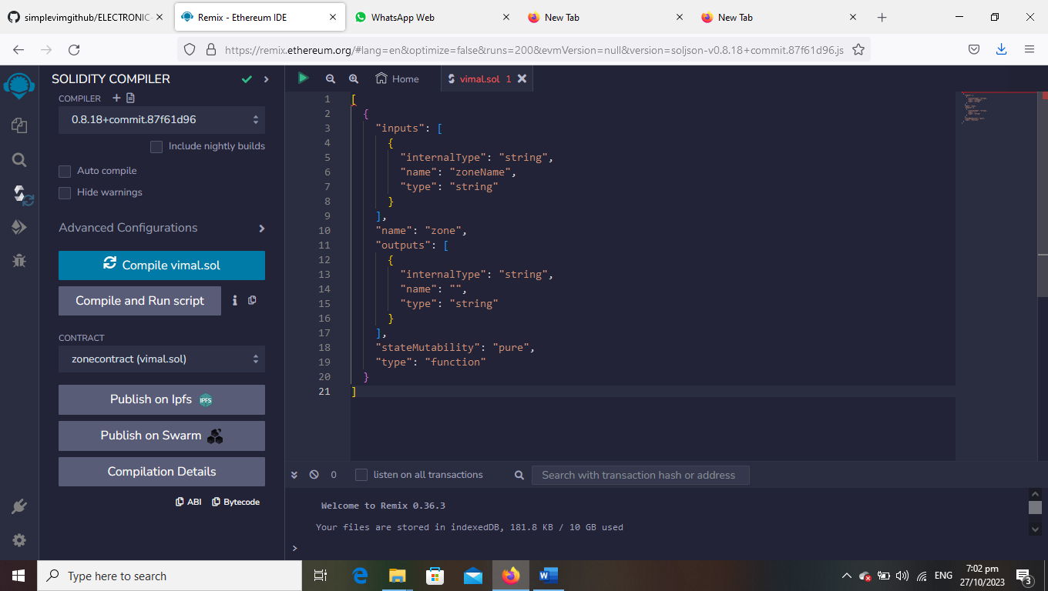

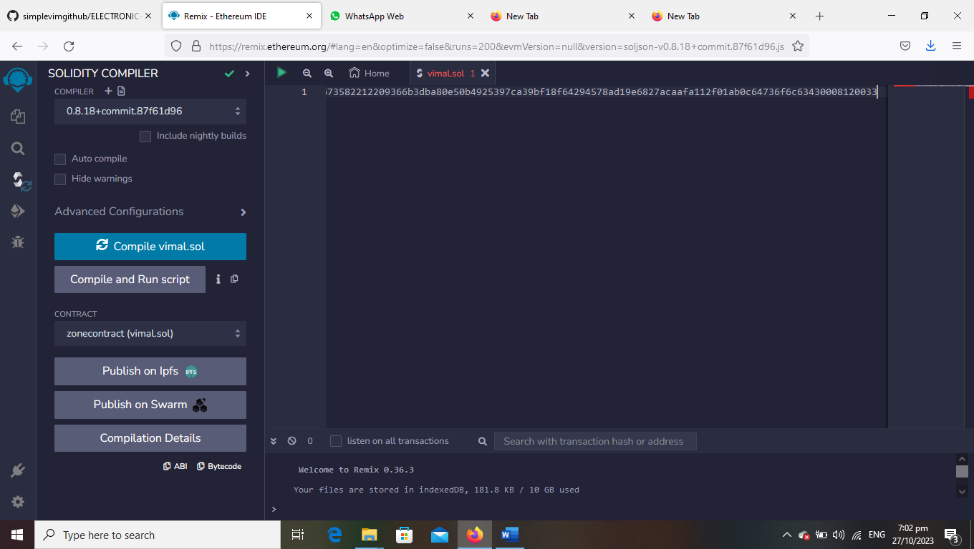

5.Deploy it to display the out put

